Titanic Survival Prediction
Data Science Project Report
Machine Learning using Logistic Regression

1. Introduction
The Titanic dataset is one of the most widely used datasets in data science and machine learning. It contains information about passengers aboard the RMS Titanic, which sank on April 15, 1912. The goal of this project is to analyze the data, uncover key patterns, and build a machine learning model to predict whether a passenger survived or not.

1.1 Objective
To understand and apply the complete data science pipeline — from data loading and cleaning to visualization and predictive modeling — using the Titanic dataset as a real-world example.

1.2 Dataset Details
Property | Value
Dataset Name | Titanic-Dataset.csv
Total Records | 891 passengers
Total Features | 12 columns
Target Variable | Survived (0 = No, 1 = Yes)
Dataset source | Kaggle

2. Tools & Technologies Used
Library | Purpose
NumPy | Numerical operations and array handling
Pandas | Data loading, cleaning, and manipulation
Matplotlib | Basic data visualization (bar charts)
Seaborn | Advanced visualizations (boxplot, heatmap)
Scikit-learn | Machine learning — Logistic Regression, evaluation metrics
Google Colab | Cloud-based Jupyter notebook environment

3. Project Workflow
The project follows a standard data science pipeline consisting of six key phases:
- Data Collection — Load the Titanic dataset
- Data Cleaning — Handle missing values and remove irrelevant columns
- Exploratory Data Analysis — Understand patterns in the data
- Data Visualization — Create charts to visualize key insights
- Feature Engineering & Encoding — Prepare data for model training
- Model Building & Evaluation — Train and evaluate Logistic Regression

4. Data Cleaning & Preprocessing

4.1 Missing Values
The dataset had missing values in three columns, handled as follows:
Column | Missing Values | Strategy Used
Age | 177 missing | Filled with mean age (~29.7 years)
Cabin | 687 missing | Column dropped (too many nulls)
Embarked | 2 missing | Filled with most common value 'S'

4.2 Columns Removed
The following columns were dropped as they do not contribute meaningfully to prediction:
- PassengerId — unique identifier, no predictive value
- Name — text field, not used in this model
- Ticket — alphanumeric ticket number, inconsistent format
- Cabin — over 77% missing values

4.3 Feature Engineering
A new feature called Family Size was created by combining SibSp (siblings/spouses) and Parch (parents/children):
df['Family Size'] = df['SibSp'] + df['Parch']
After cleaning, the final dataset contained 202 rows and 9 columns.

5. Categorical Encoding
Machine learning models require numerical inputs. The following categorical columns were encoded:
Column | Encoding
Sex | male = 0, female = 1
Embarked | S = 0, C = 1, Q = 2

6. Exploratory Data Analysis & Visualizations

6.1 Survival Rate
A bar chart was plotted to show the overall survival rate. The chart revealed that approximately 65% of passengers in the cleaned dataset survived, compared to ~38% in the full original dataset. This skew is due to the cabin-based filtering.
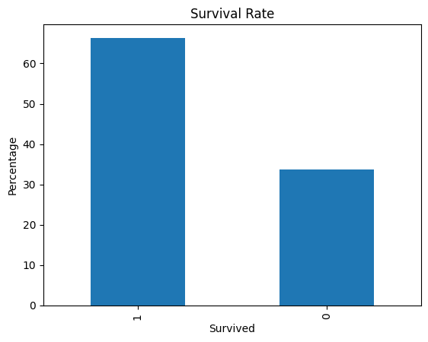

6.2 Survival by Gender
A groupby analysis revealed a stark difference in survival rates by gender:
Gender | Survival Rate
Female | 93.68%
Male | 42.06%

This confirms the historical record: women were given priority in lifeboats, resulting in a significantly higher survival rate.

6.3 Fare Distribution by Class
A boxplot was used to visualize fare distribution across passenger classes. Key findings:
- Class 1 passengers paid significantly higher fares, with a wide spread due to outliers (max fare: Rs.512.33)
- Class 2 fares were moderate and consistent
- Class 3 fares were the lowest with very little variation
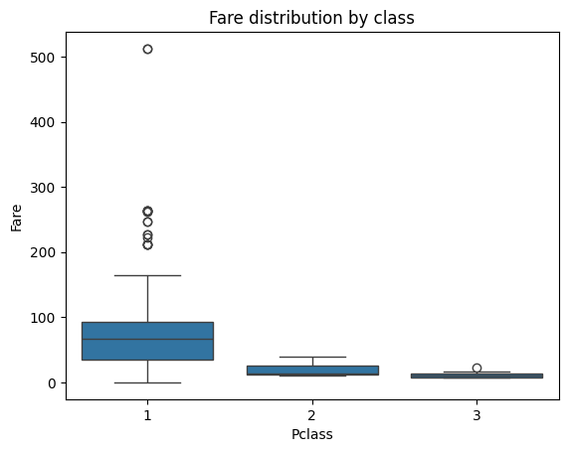

7. Machine Learning Model

7.1 Algorithm: Logistic Regression
Logistic Regression was chosen as the algorithm because:
- It is well-suited for binary classification problems (Survived: Yes/No)
- It is interpretable and works well on small-to-medium datasets
- It serves as an excellent baseline model for benchmarking

7.2 Train-Test Split
Split | Size | Rows (approx.)
Training Set | 80% | ~161 rows
Test Set | 20% | ~41 rows
Parameters used: test_size = 0.2, random_state = 42

7.3 Model Configuration
model = LogisticRegression(max_iter=1000)
max_iter=1000 was set to ensure the model converged properly on this dataset.

8. Model Evaluation & Results

8.1 Accuracy
The model achieved an accuracy of approximately 82.93% on the test set.
Metric | Value
Test Accuracy | 82.93%
Test Set Size | 41 passengers

8.2 Confusion Matrix Analysis
The confusion matrix results were:
 | Predicted: Did Not Survive (0) | Predicted: Survived (1)
Actual: Did Not Survive (0) | 5 (True Negatives) | 3 (False Positives)
Actual: Survived (1) | 4 (False Negatives) | 29 (True Positives)
Interpretation:
- True Positives (29): Passengers who survived and were correctly predicted as survivors
- True Negatives (5): Passengers who did not survive and were correctly predicted
- False Positives (3): Passengers predicted to survive but actually did not
- False Negatives (4): Passengers predicted not to survive but actually did
The model performs well, especially in identifying survivors (high recall for class 1).
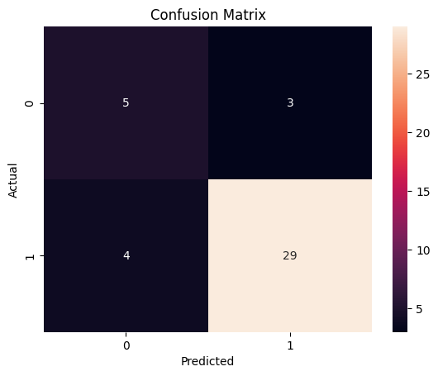

9. Key Findings & Insights
- Gender was the strongest predictor of survival — females had a 93.68% survival rate vs 42.06% for males
- Passenger class strongly correlated with fare paid and likely survival (1st class had the highest fares)
- The youngest passengers (as young as 0.92 years) were among the survivors
- Most passengers travelled alone or in small families
- The maximum fare paid was Rs.512.33, by a 1st class passenger

10. Conclusion
This project successfully demonstrates a complete data science workflow applied to the Titanic dataset. Starting from raw data, we performed data cleaning, exploratory analysis, feature engineering, and built a Logistic Regression model that achieved 82.93% accuracy on the test set.
The project reinforces the importance of each stage in the data science pipeline — especially data cleaning — as the quality of the final model is heavily dependent on how well the data is prepared. Future improvements could include trying ensemble models (Random Forest, XGBoost), better handling of the Cabin column, and using cross-validation for more robust evaluation.

11. Files Submitted
File | Link | Description
Titanic-Dataset.csv |  | Original raw dataset
Titanic-Colab.ipynb |  | Jupyter notebook with full code
Cleaned Dataset.csv |  | Preprocessed dataset saved after cleaning
Project Report (this file) |  | Complete project documentation

Titanic Survival Prediction | Data Science Project

